How to Format Your Paper for ICCSCM

First Author1, Second Author2 and Third author3

1ABC University, School of PQR,

2School of JKL, XYZ University,

Corresponding addresses   
{first author, second author, third author}@email.com

*Abstract*: These instructions provide you guidelines for preparing papers for Conference on Computer Science & Computational Mathematics*.* Use this document as a template and as an instruction set.

*Keywords*: about three to six key words separated by commas.

# Introduction

When you submit your paper print it in two-column format, including figures and tables. In addition, designate one author as the “corresponding author”. This is the author to whom proofs of the paper will be sent. Proofs are sent to the corresponding author only.

# Page Size and Layout

Set your page as A4, width 210, height 297 and margins as follows:

* Left Margin 17 mm (0.67")
* Right Margin 14.5 mm (0.57)
* Top Margin – 22 mm (0.87")
* Bottom Margin – 18 mm (0.71")

You should use Times Roman of size 10 for all fonts in the paper. Format the page as two columns:

* Column Width 86.8 mm (3.42")
* Column Height – 271.4 mm (10.69")
* Space/Gap between Columns - 5.0 mm (0.2")
* Line Spacing of the Context-Multiple At 1.05

# Title, Authors, Body Paragraphs, Sections Headings and References

## Title and authors

The title of the paper is centered 17.8 mm (0.67") below the top of the page in 24 point font. Right below the title (separated by single line spacing) are the names of the authors. The font size for the authors is 11pt. Author affiliations shall be in 9 pt.

## Body paragraphs

The main text for your paragraphs should be 10pt font. All body paragraphs (except the beginning of a section/sub-section) should have the first line indented about 3.6 mm (0.14").

### Figures and Tables

Place illustrations (figures, tables, drawings, and photographs) throughout the paper at the places where they are first discussed in the text, rather than at the end of the paper. Number illustrations sequentially (but number tables separately). Place the illustration numbers and caption under the illustration in 10 pt font. Do not allow illustrations to extend into the margins or the gap between columns (except 2-column illustrations may cross the gap). If your figure has two parts, include the labels “(a)” and “(b)”.

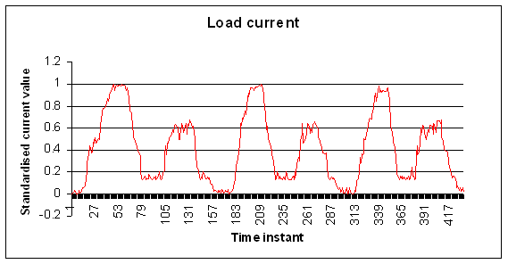

**Figure 1.** Testing data- load current (amperes)

### Tables

Place table titles above the tables.

**Table 1.** Best results

|  |  |  |
| --- | --- | --- |
| Load time | Frequency | Total Cost |
| Seconds | Eight | None |
| Minutes | Nine | More |

### Sections headings

Section headings come in several varieties:

1. first level headings: **1. Heading 1**
2. second level: **1.2 Heading 2**
3. third level: *1.2.3 Heading 3*
4. forth level: *(a) Heading 4*
5. fifth level: (1) Heading 5
6. sixth level: *(a) Heading 6*

### References

Number citations consecutively in square brackets [1]. The sentence punctuation follows the brackets [2]. Multiple references are [2, 3] or [1-3]. Please note that the references at the end of this document are in the preferred referencing style. Please ensure that the provided references are complete with all the details and also cited inside the manuscript (example: page numbers, year of publication, publisher’s name etc.).

# Equations

If you are using *Word,* use either the Microsoft Equation Editor or the *MathType* add-on (http://www.mathtype.com) for equations in your paper (Insert | Object | Create New | Microsoft Equation *or* MathType Equation). “Float over text” should not be selected.

Number equations consecutively with equation numbers in parentheses flush with the right margin, as in (1). First use the equation editor to create the equation. Then select the “Equation” markup style. Press the tab key and write the equation number in parentheses.

 (1)

Proofs should end with a box. ◻

# Other recommendations

Equalize the length of your columns on the last page. If you are using *Word*, proceed as follows: Page Layout / Break / Continuous.

**References**

1. Author 1, Author 2, Title of paper/chapter, *Name of Journal/ Conference/ Book*, Vol x, No. x, pp. x-x, Year.
2. H. Poor, An Introduction to Signal Detection and Estimation. *Springer-Verlag*, New York, ch. 4, 1985.
3. M. Young, *The Techincal Writers Handbook*. Mill Valley, CA: University Science, 1989.
4. J. U. Duncombe, “Infrared navigation—Part I: An assessment of feasibility (Periodical style),” *IEEE Trans. Electron Devices*, vol. ED-11, pp. 34–39, Jan. 1959.
5. R. W. Lucky, “Automatic equalization for digital communication,” *Bell Syst. Tech. J.*, vol. 44, no. 4, pp. 547–588, Apr. 1965.
6. S. P. Bingulac, “On the compatibility of adaptive controllers (Published Conference Proceedings style),” in *Proc. 4th Annu. Allerton Conf. Circuits and Systems Theory*, New York, 1994, pp. 8–16.